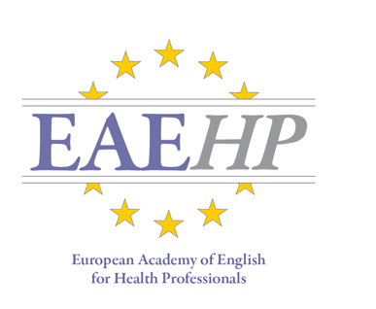

European Academy of English for Health Professionals

in partnership with
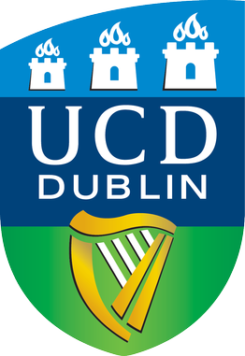

University College Dublin

Intensive English Course for Radiographers

WHAT? Intensive English Course delivered for Radiographers
WHERE? University College Dublin, Ireland
WHEN? 13th- 17th June 2022

OVERVIEW
The course provides Radiographers with a deeper understanding and knowledge of English and helps improve technical vocabulary related to their professional fields. Our principal goal is to help Radiographers to communicate effectively and accurately through English in their working lives. Additionally, the course aims to help Radiographers and student Radiographers develop skills in writing scientific abstracts and delivering conference presentations.

TARGET
The course is aimed at practicing or student radiographers who may have English-speaking patients; who wish to participate in international conferences; and who are considering submitting abstracts for conference presentations in English.

PRINCIPAL COURSE CONTENT
• Medical terminology (including profession specific terminology)
• Patient communication
• Public speaking, presentation skills and preparing for conference presentation
• Interactive practical workshops with a professional focus
• Radiography 3D Virtual Reality workshop
• University Hospital tour and meeting with local Radiographers

OBJECTIVES
Develop your capacity to:
• use English with confidence in the workplace
• hold conversations with international colleagues
- engage with published research related to your profession
• give presentations and actively participate in conferences
• use technical vocabulary specific to your field

APPROACH
This intensive course is highly interactive. You will develop specific language areas through small group activities, role play and by using medical equipment specific to your profession. Classes are student focused and will have a maximum of 15 participants per professional group. Our English language services are designed to meet the needs of our customers, and are delivered by a healthcare professional in an equivalent role.

COURSE FEES

The cost includes all classes, interactive lessons, and hands-on practical sessions.

Radiographers course fee: 800,00 €
Radiographers course fee (for students and unemployed*): 550,00 €

ACCOMMODATION
The following accommodation options are available (breakfast is included):

June, Sunday 12th – Saturday 18th

Accommodation with selected host families: 280 €

All subject to availability and early bookings are recommended.

* The EAEHP Administrative team will undertake checks as required to establish whether EAEHP students are currently undertaking
undergraduate studies or on their employment status. Any false declarations with regard to registration categories listed above will result in certificates of completion being withheld and a request for the fee balance to be paid.

CONTACT US

Would you like to learn more?
We are available by e-mail: info@eaehp.org

APPLICATION FORM

Intensive English Courses for Radiographers – University College Dublin
13th – 17th June 2022
Course codes:
Radiographers: IUR122
Deadline for application: Monday 16th May 2022

Please fill in and send to info@eaehp.org

First Name:______________________________________________________________________________
Last Name: ______________________________________________________________________________
Address:________________________________________________________________________________
City/State___________________________________________________________________________
E-mail:__________________________________________________________________________________
Phone number: __________________________________________________________________________
Place and Date of Birth: ___________________________________________________________________

Profession: Radiographer

Qualification: employed student unemployed

Place of work: ___________________________________________________________________________

Accommodation required? YES NO

Any additional information:

___________________________________________________________________________

Place and date Signature

_________________________ _______________________________

PAYMENT
Please send an International Transfer to European Academy of English for Health Professionals:
Bank AIB - Swift Code: AIBKIE2D - IBAN: IE80AIBK93015627136068
IMPORTANT: PLEASE MAKE SURE TO INCLUDE THE NAME OF THE STUDENT IN THE “REASON FOR PAYMENT” FIELD

A deposit of €250 is required following submission of the Application Form.

Balance to be paid by May 16th, 2022

Professional English Language Courses for Radiographers

Course content themes:
- Technical language for Radiographers and Physiotherapists;
- Communication with patients in English;
- Preparing for conference presentations.

Technical language for Radiographers:
Dedicated sessions will be provided which will cover the key terminology used in general radiography and imaging specialities such as CT, MRI and Nuclear Medicine. Moreover, we deliver sessions about radiotherapy, the radiography profession in Europe and radiation safety regulations. There will also be a radiographic image viewing sessions focusing on image critique, 3D Virtual Reality Radiography, radiographic anatomy and pathology. A published peer-reviewed journal article will be reviewed in order to familiarise participants with the language used. A glossary of key terminology used will be provided for all participants along with associated activities.

Communication with patients in English:
Separate practical role-play scenarios for radiographers and physiotherapists will be conducted in the clinical skills laboratories at the University of Malta. Participants will interact, discuss and formulate questions that are directed at patients, use terminology related to the associated area of expertise, how best to explain something to patients, and use terminology related to equipment specific for radiography and physiotherapy.

Preparing for conference presentations:
This will start with the first stage of presenting at a scientific conference i.e. submission of an abstract. A scientific abstract related to your area of expertise will be reviewed and discussed in small groups and a presentation delivered on this topic followed by questions and answers. Presentation skills will be covered throughout the course through sessions exploring presentation structure, useful phrases, and linking sections. Sample videos of good and bad scientific presentations will be reviewed in class. Participants will be required to give an informal initial presentation followed by a short, formal scientific presentation at the end of the course.

Other Course features:

- Sessions will be delivered by a number of expert Radiography lecturers.
- A clinical visit at the local General Hospital highlighting roles and responsibilities of both professions in Malta will be included;
- Accommodation can be provided for 6 nights (bed and breakfast) with selected host families close to the University;
- There will be a maximum of 15 students per professional group;
- Certificate of completion will be presented to all participants at the end of the course;
- 5 ECTS credits will be issued to each participant upon successful completion of the course;
- Social and cultural activities will be organised during the course for interested participants

